**Scripting Task**

**Task 1:**

* Created the Folder called Task4 and moved to that folder.
* Created on bash script file called task4.sh and provided the execution permission

| **Chmod +x task4.sh** |
| --- |

* Wrote the script for identify the guvi.in HTTP error_code and print the success/failure Statement based on the HTTP error_code.

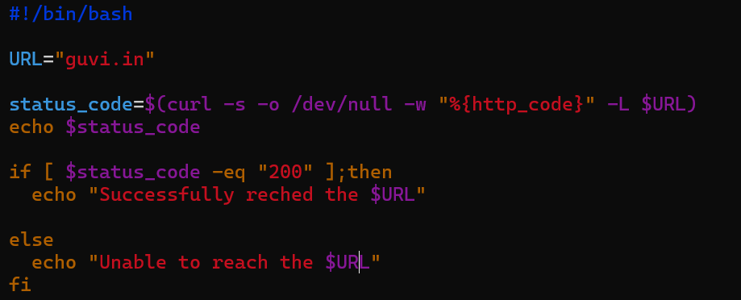

* Executed that file **./task4.sh.**

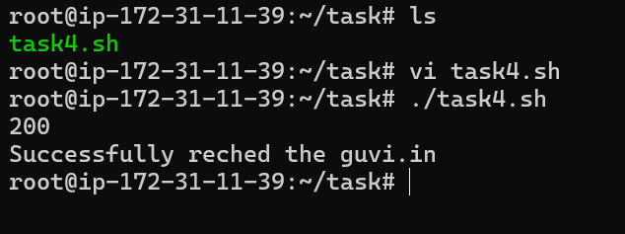

**========================================================================**

**Task 2:**

* I have created the file called “source_file.txt” with have multiple lines.

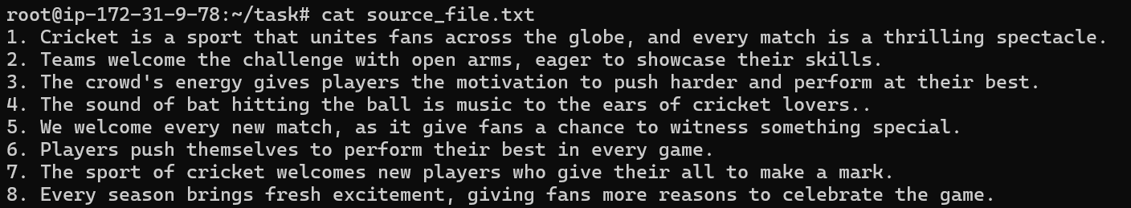

* Created the one scripting file called “task.sh” and provided the execution permission.

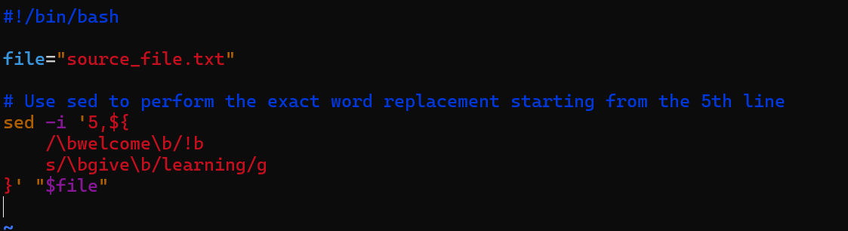

* Sed → command performs a simple search-and replace operation or modify the text in place.
* -i → This parameter make changes the directly to the original file.
* 5,$ → It will start the search from line 5th and end of the file.
* /b → If used /b, It consider the whole word should be exactly mach.
* !b → not match the word it will move to next line.
* /bwelcome/b → Its for searching word.
* {....} → To replace the word.
* \bgive\b and \blearning\b → replace the words.
* s → keyword specifies that the operation performed in the following command is substitution
* g → parameter indicates applying a substitution along the entire line.
* Executed the file ./test.sh . It replaced the words.

